TRAVEL GUIDE

Alec Jon Lima

455012

3102 – Cloud Application Requirements and Specifications

September 18, 2023

# Table of Contents

Table of Contents 2

Lab 1 – My Experiences 3

Part <n> 3

Description 3

Preparation 3

Observations 3

Screenshots 4

Reflection 8

References 8

# Lab <n> - <Lab Name>

# Part <n>

## Description

**The purpose of our lab is to share with the audience how travel guide works. Additionally, viewers can learn important details about the destination that we're offering. It will also enable us to give some good deals when they book with us.**

## Preparation

* Make sure to write down the design that you want for your website.
* Include all the functions that you want to happen inside your website.
* Gather all resources that you need like the images, background images, data and a lot more.
* Once done, you can start creating your website
  + Tools/Resources needed: VS Code, Pelex, W3Schools, YouTube, GitHub

## Observations

I discovered that your website can be used for a wide variety of purposes. several features that can be added to your website. We can quickly determine whether we need to change the design or anything else thanks to real-time updates. I may have some useless codes on the website, but I'm sure I can get better at making websites in the future.

## Screenshots

Homepage

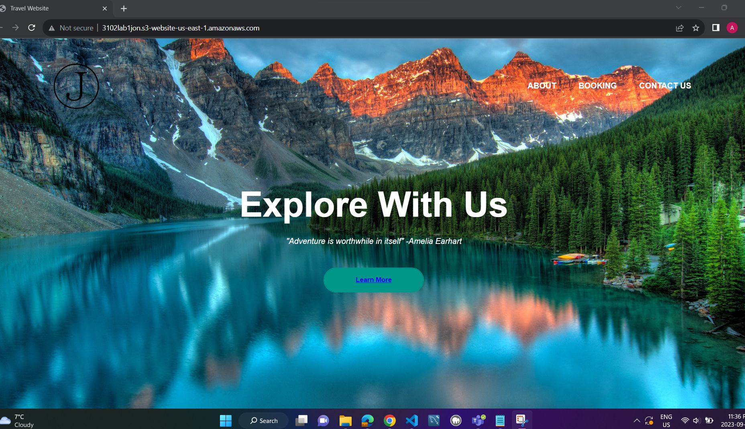

About page

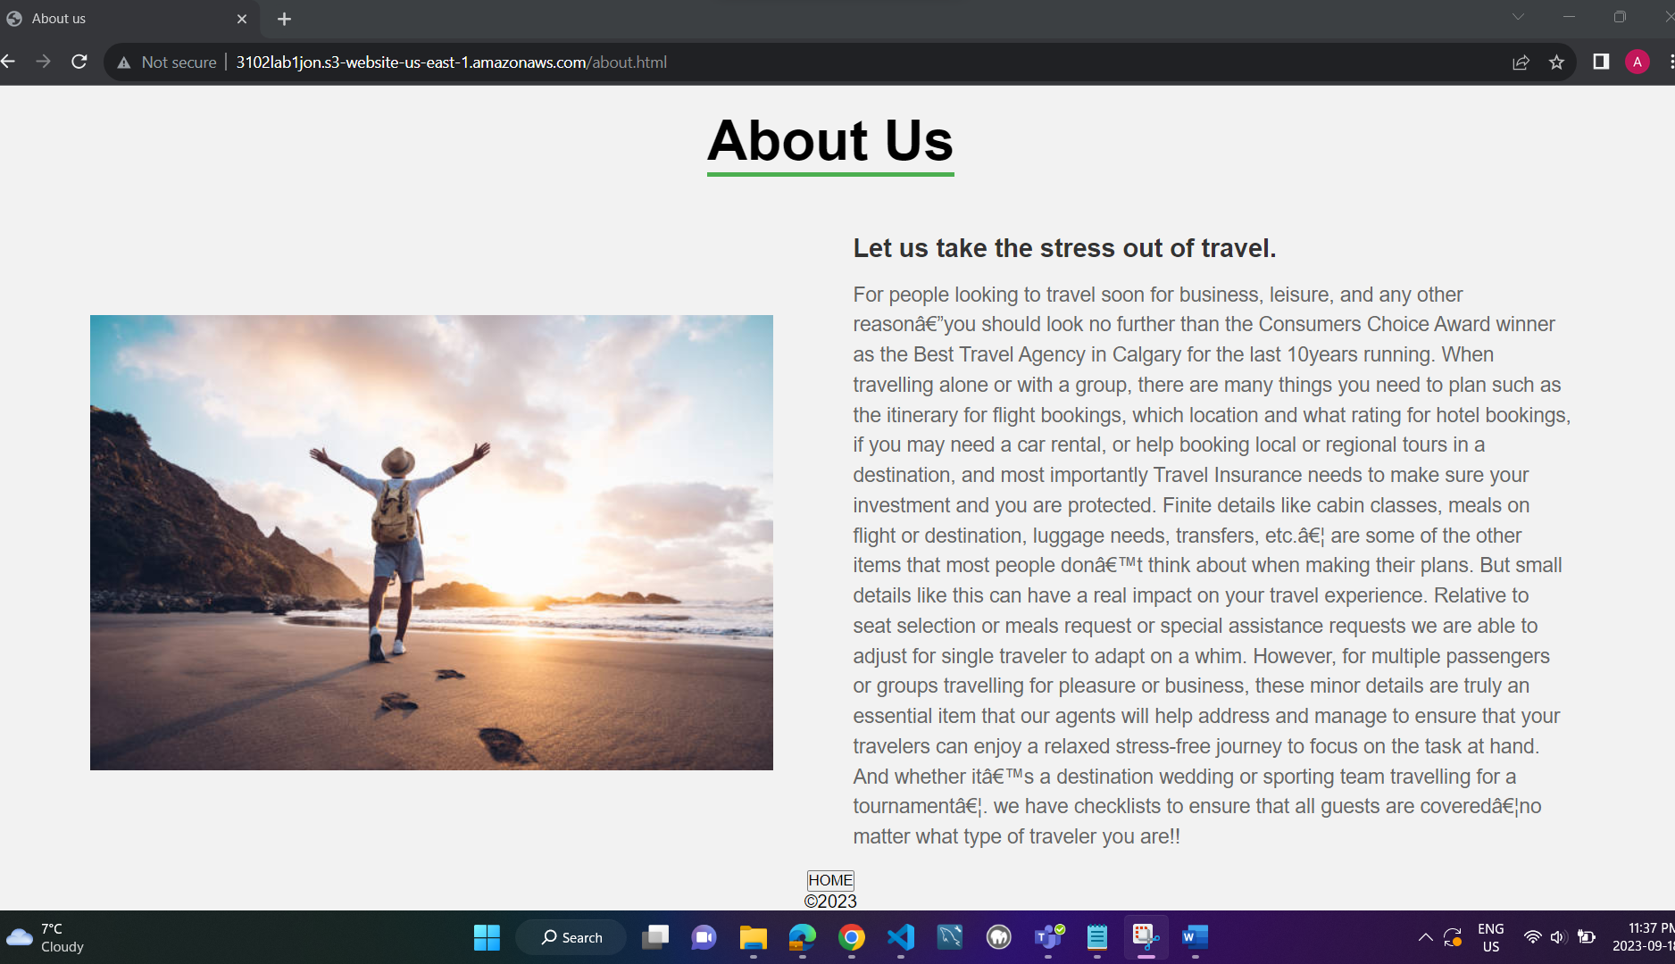

Learn More page

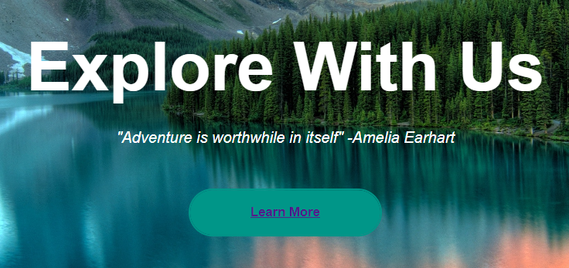

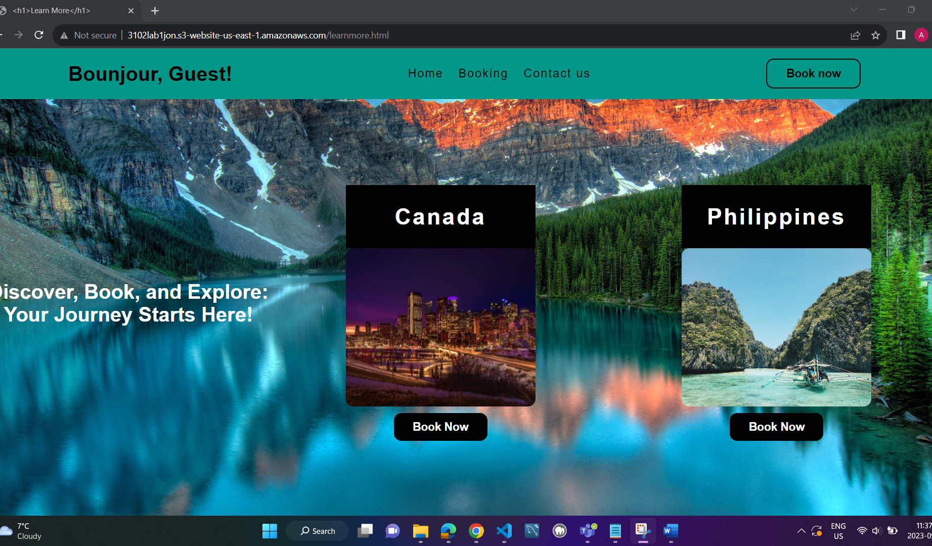

“Contact Us” page

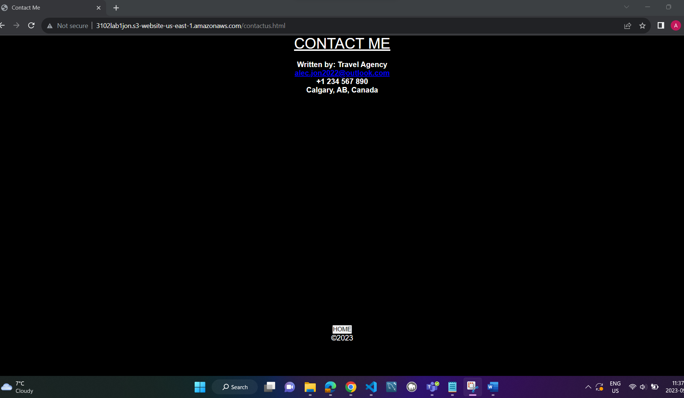

“Book Now/Booking page

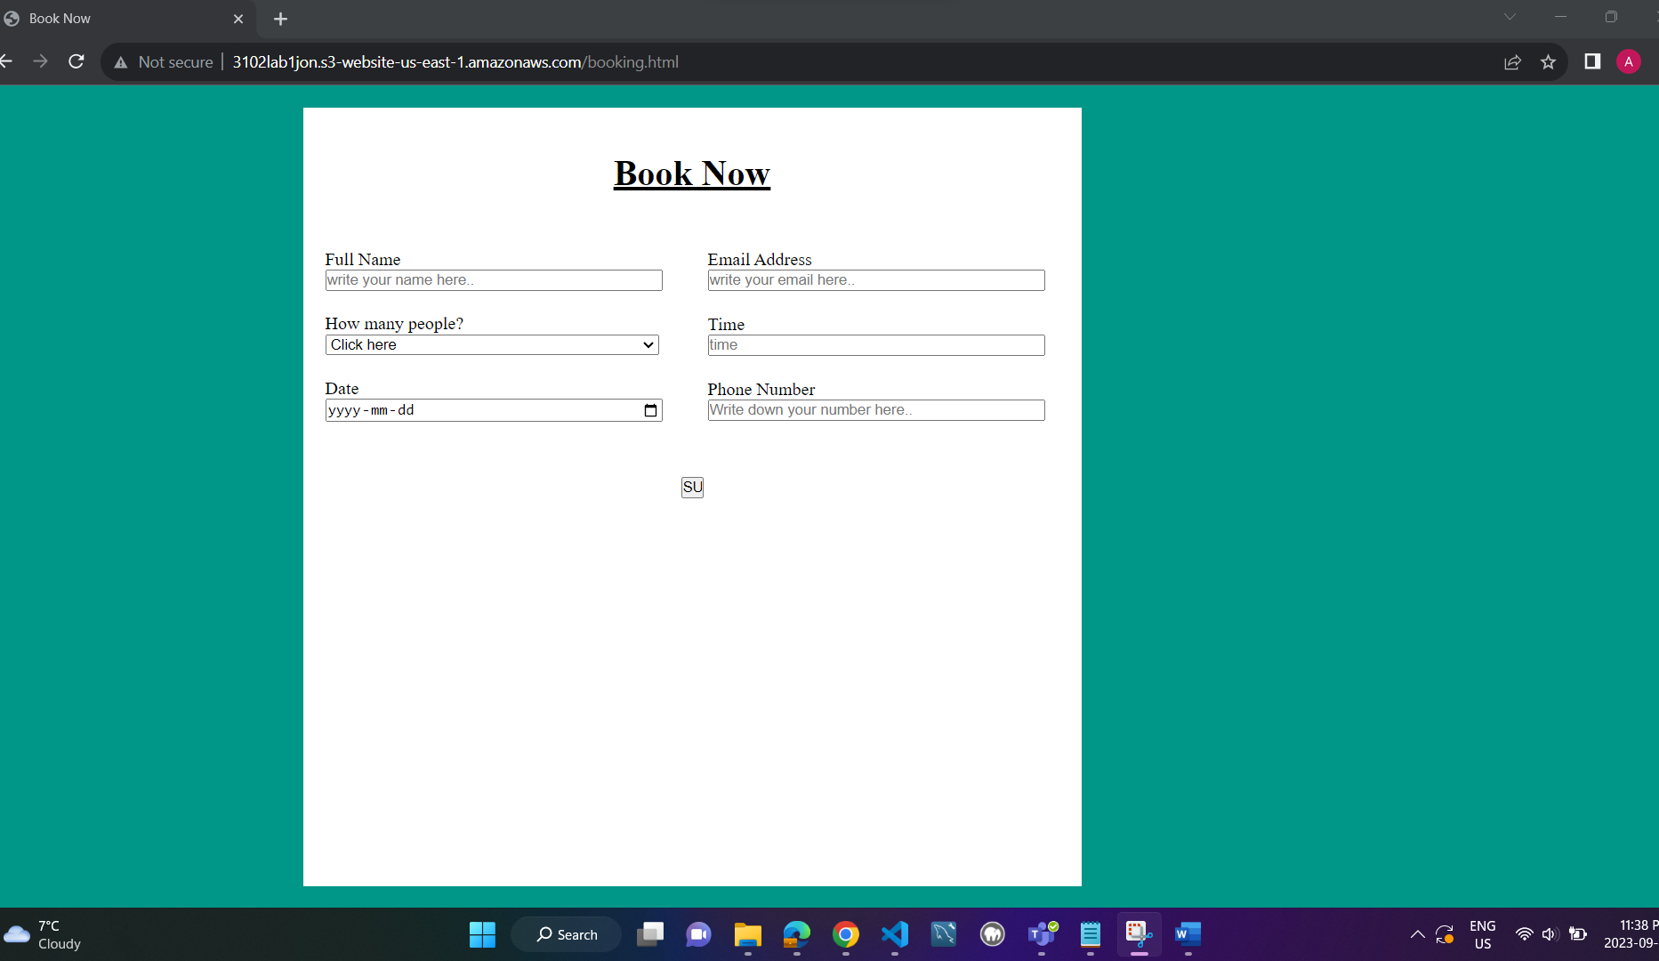

Home button (it will go back to the homepage)

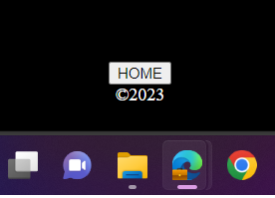

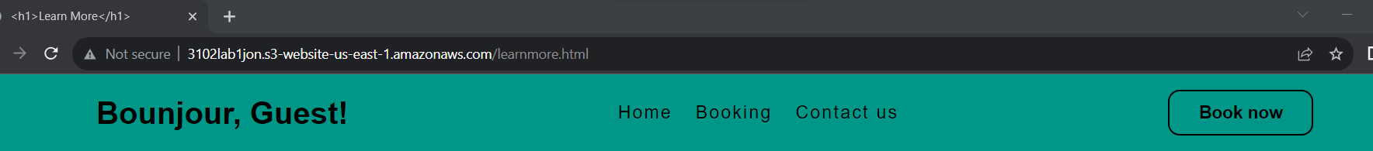

After clicking my email address

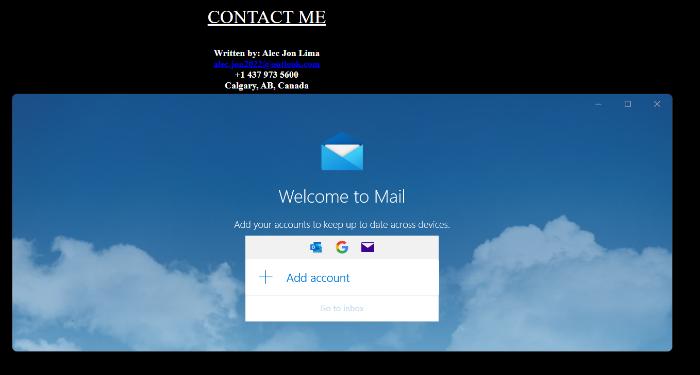

## Reflection

I can state that it is not that simple and takes a lot of time now that I have finished building my own travel website. I had to spend a lot of time learning some commands. Some of the text, buttons, and photos are extremely difficult to align. I have to look up a lot of information before I can figure out what to do or what I need to grasp.

Overall, I was incredibly happy with the website's outcome even though there's a lot more to improve in regards to the functionalities and the looks.

# References

* <https://www.youtube.com/watch?v=P7iB6nvfnR8>
* <https://www.youtube.com/watch?v=cUXcqkXN83Q>
* <https://www.w3schools.com/html/default.asp>
* <https://www.w3schools.com/css/default.asp>
* <https://www.youtube.com/watch?v=Rqo_1TV7wQs>
* <https://www.pexels.com/search/about%20us/>
* <https://airlineticketcentre.ca/>
* [https://airlineticketcentre.ca/the-best-travel-agency-in-calgary-ab/?gclid=CjwKCAjw6p-oBhAYEiwAgg2PgqBi3LUYtbx88CyK6HmcjzvVzXHCgyy-FJ0LPslxAlLidtv5oaDyshoCskcQAvD_BwE#](https://airlineticketcentre.ca/the-best-travel-agency-in-calgary-ab/?gclid=CjwKCAjw6p-oBhAYEiwAgg2PgqBi3LUYtbx88CyK6HmcjzvVzXHCgyy-FJ0LPslxAlLidtv5oaDyshoCskcQAvD_BwE)
* [How To Make Website Using HTML And CSS | Website Design With HTML And CSS - YouTube](https://www.youtube.com/watch?v=PgAZ8KzfhO8)
* [HTML Tutorial | Learn HTML in Detail - Scaler Topics](https://www.scaler.com/topics/html/)
* [css - How to create two HTML buttons side by side - Stack Overflow](https://stackoverflow.com/questions/52544089/how-to-create-two-html-buttons-side-by-side)
* [HTML: HyperText Markup Language | MDN (mozilla.org)](https://developer.mozilla.org/en-US/docs/Web/HTML)